**System Design**

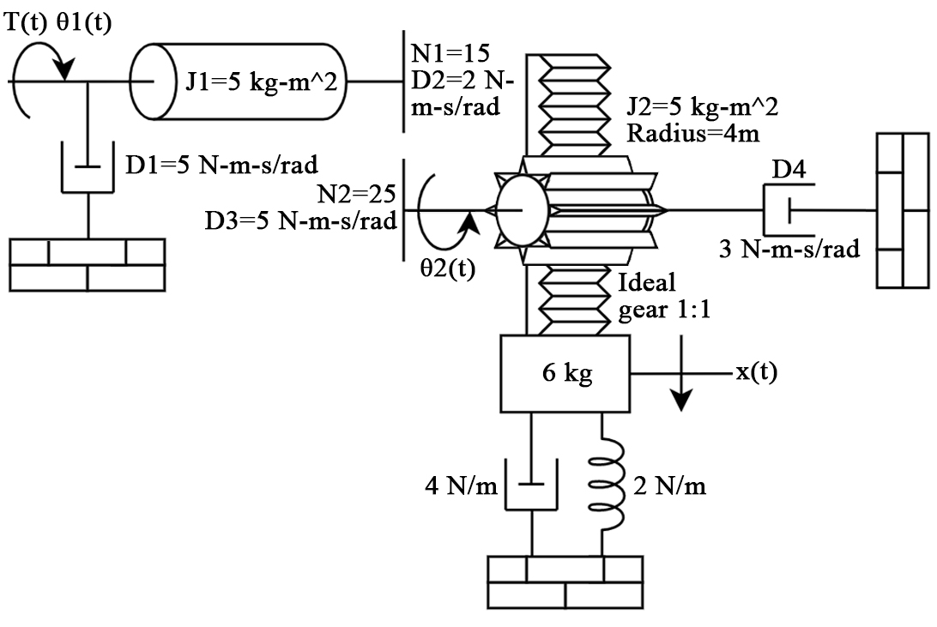

**Transfer Function**

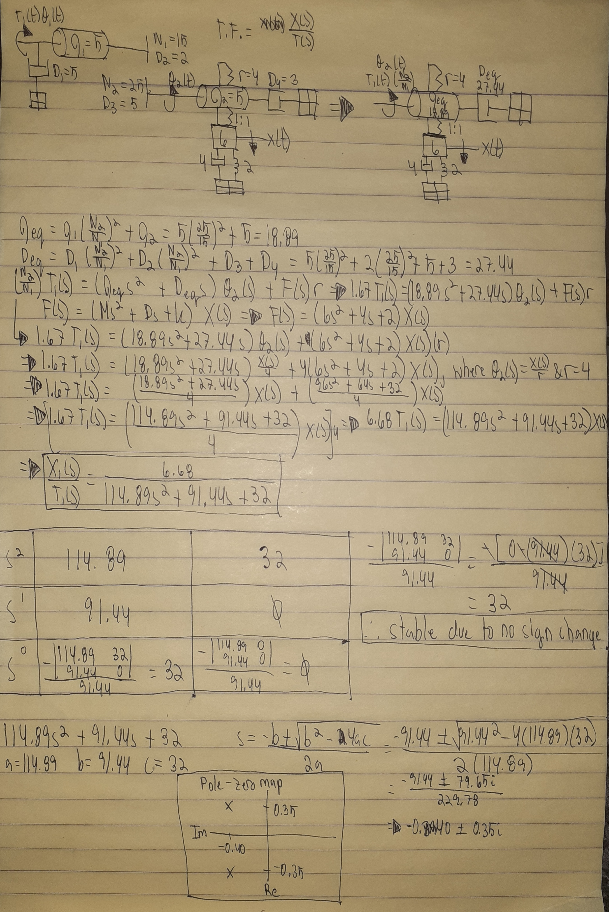

**PID Controller**

1. Original

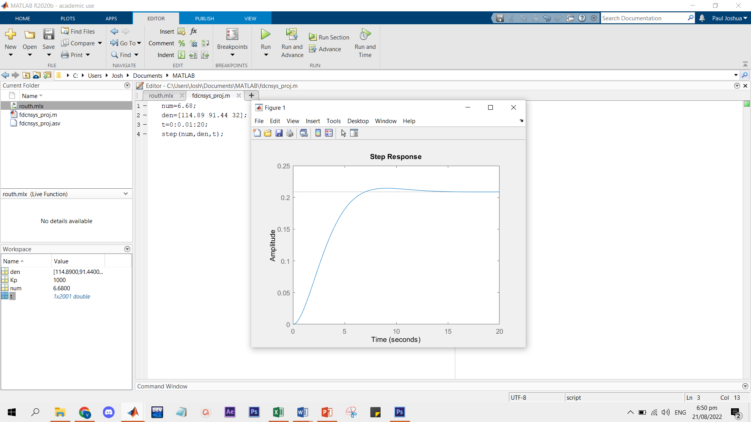

2. Modified

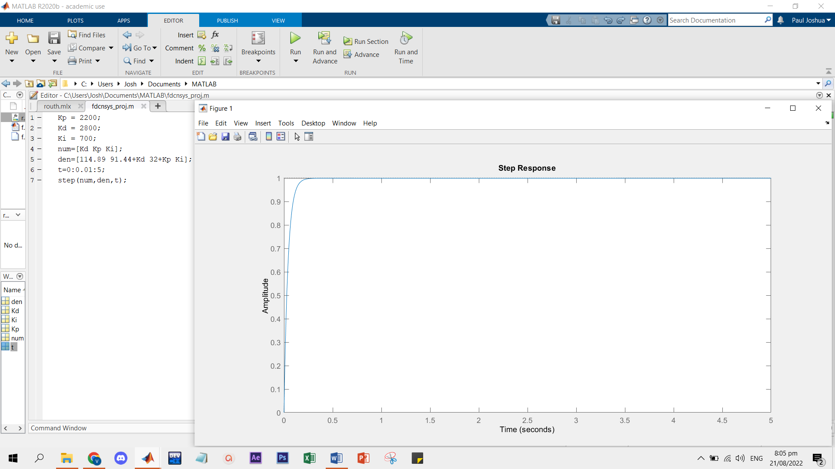

**Routh Table**

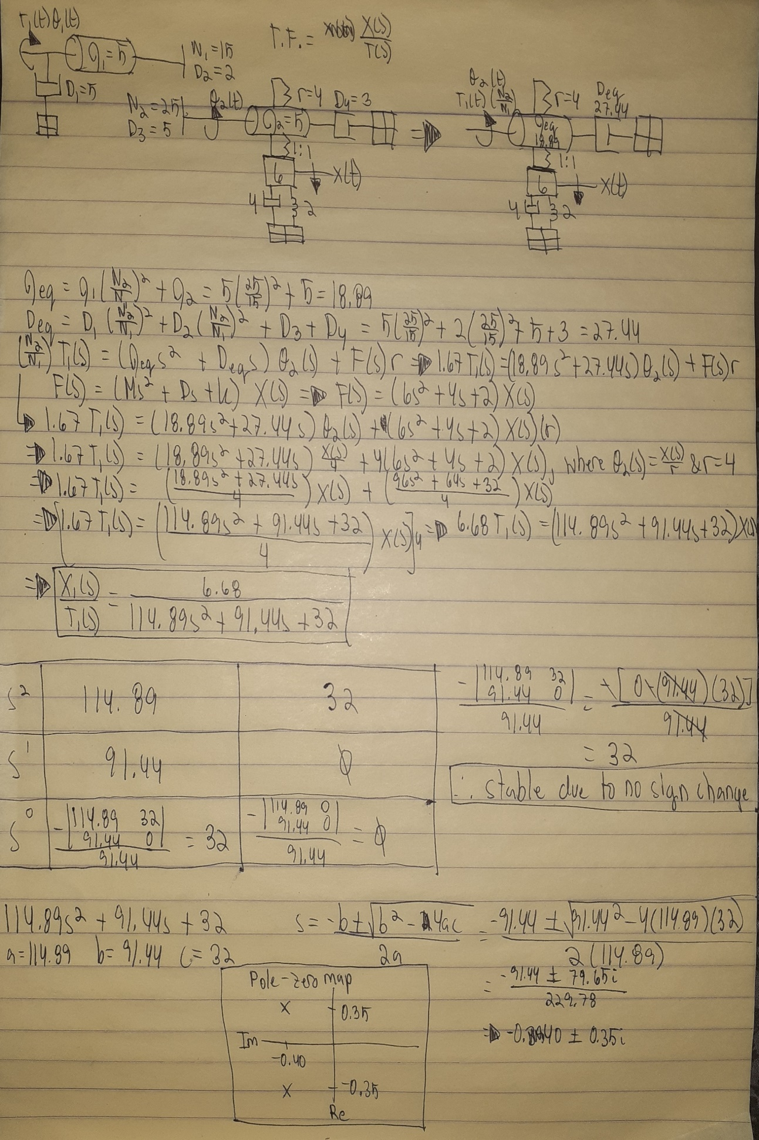

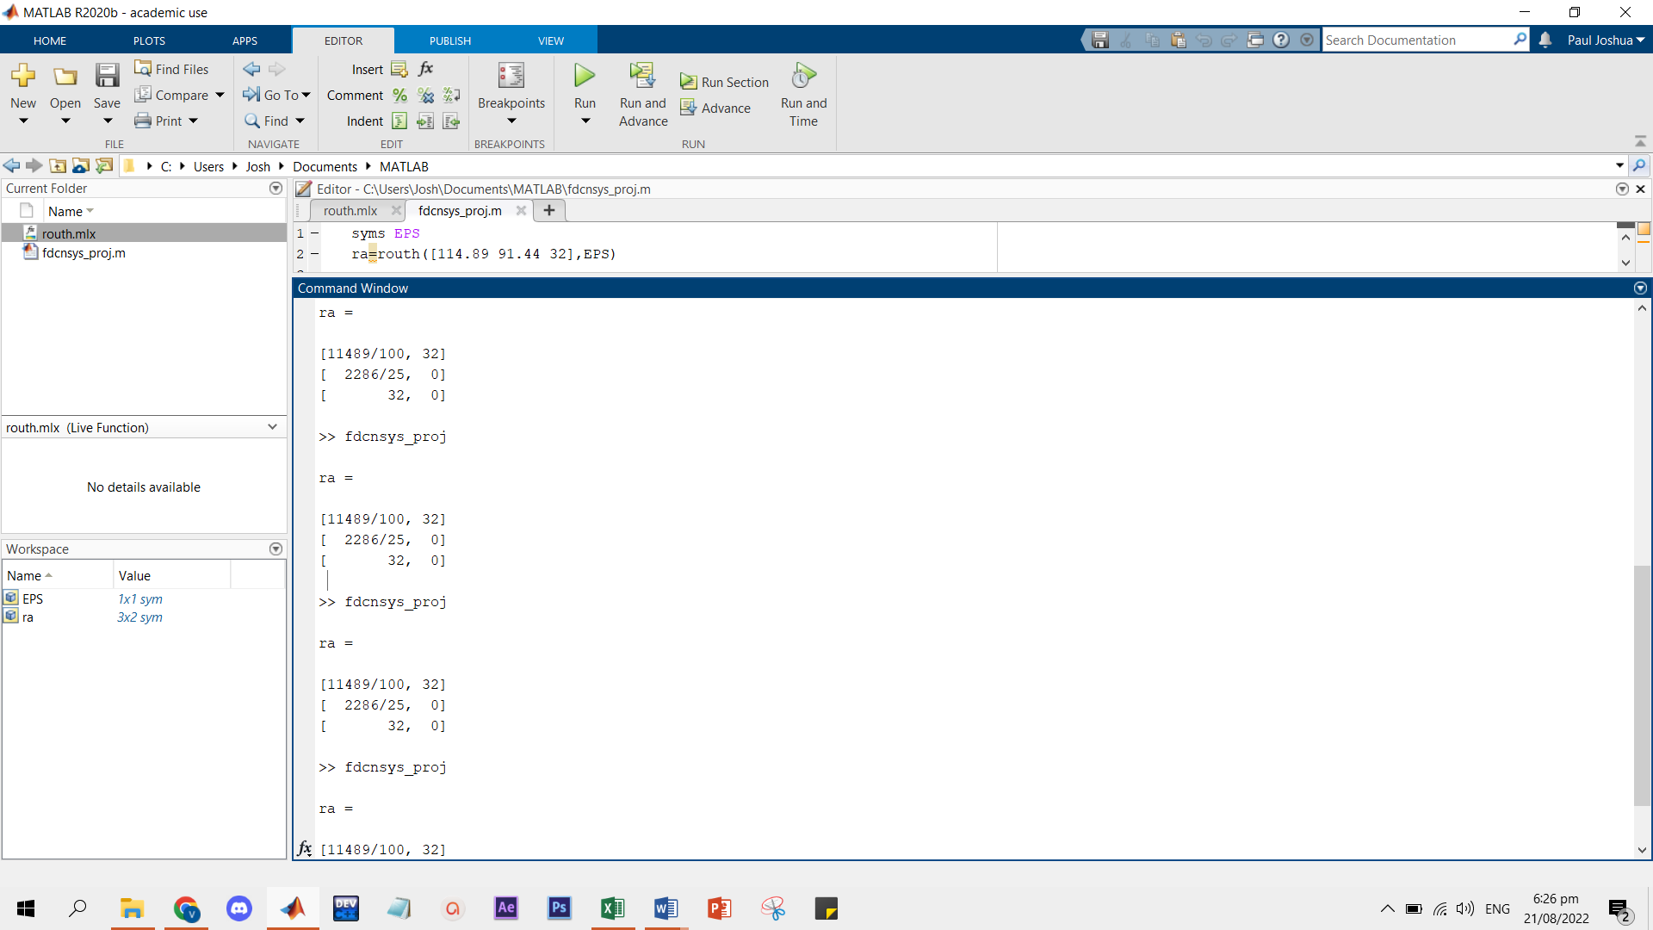

**Pole-Zero Map**

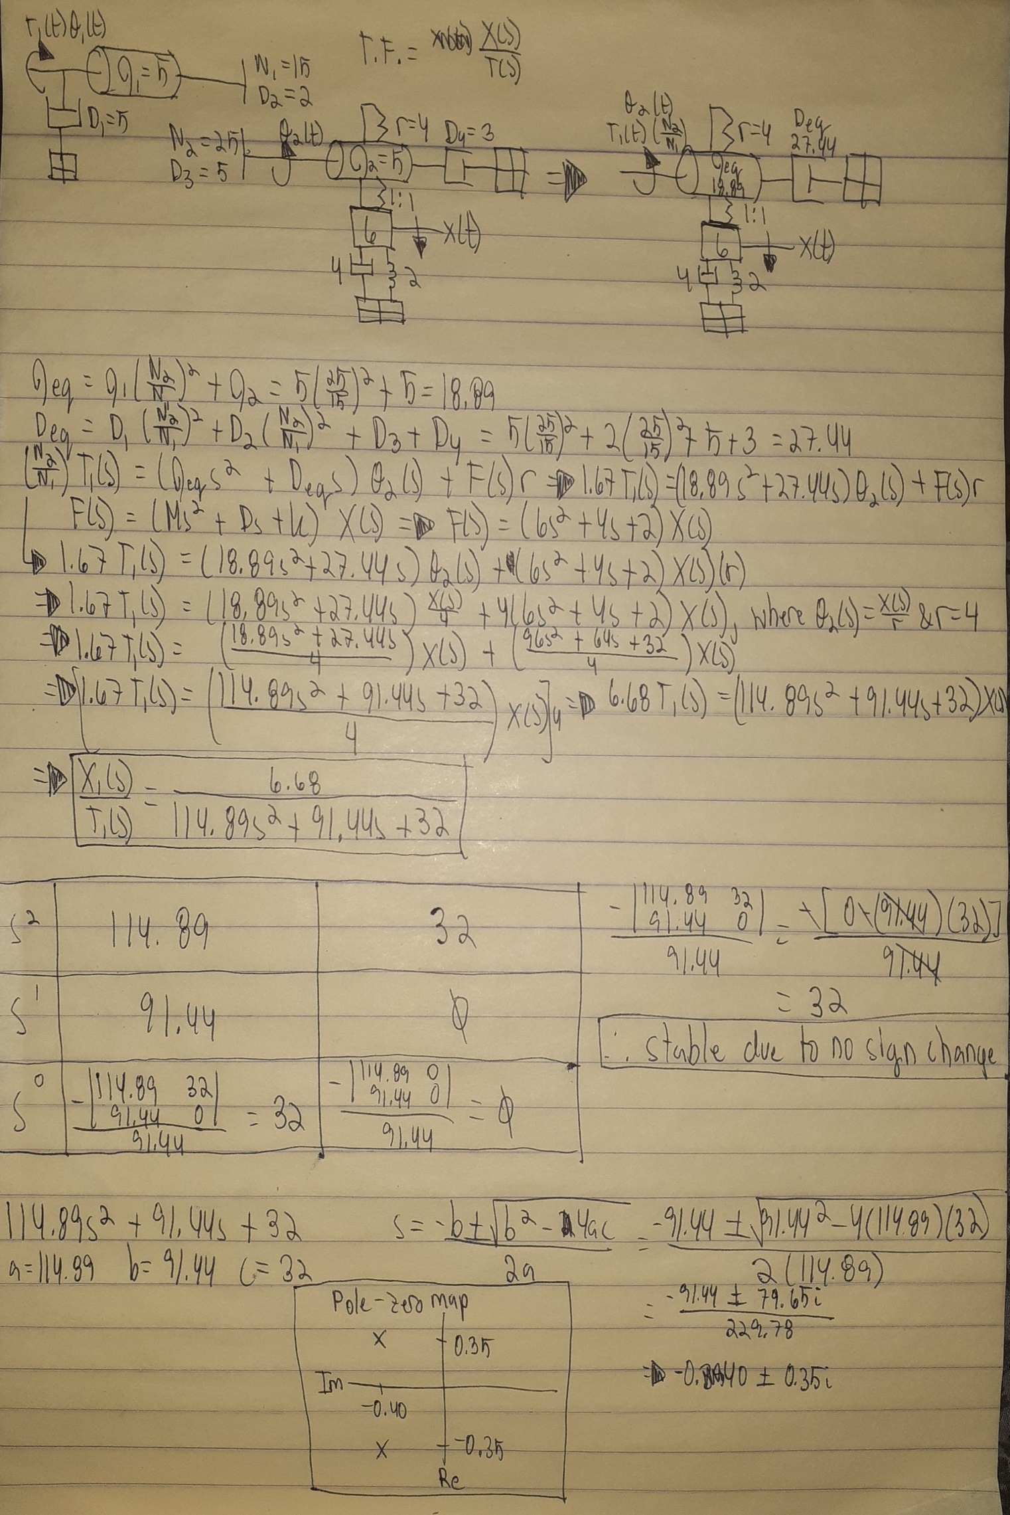

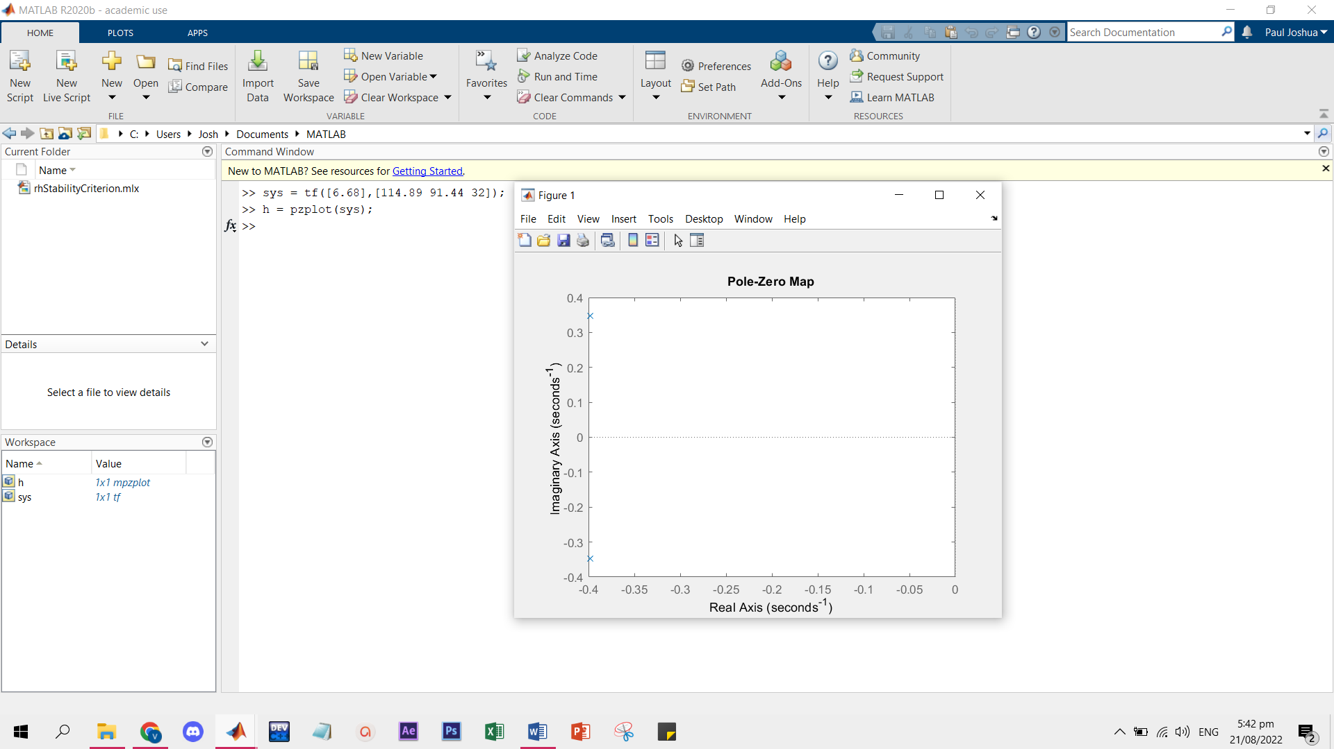

**State Space Representation**

Explanation: The controllable canonical form is shown in the left image, given the transfer function. However, MATLAB’s tf2ss function output is not yet in controllable canonical form. To reformat the output, matrix A is flipped horizontally and vertically while matrix B and C are interchanged and transposed, while D remains the same.